Friday, 18th October 2024 SWS/ACD/2024-25/81

Dear Parent

Greetings from Smart Wonders!

We are pleased to inform you that the regular timetable will resume from Monday, 21st October 2024. This will ensure a smooth transition back to the regular academic routine for all our students after the Annual show on Saturday, 19th October 2024.
Please ensure that your ward packs the bag as per the time table from Monday, 21st October 2024 onwards.

Warm regards
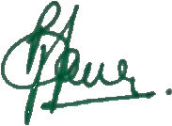
Poonamjit Kaur
Principal

